DMV Assignment 4

Syed Muhammad Hassan Raza – 26645

Question 1: List the department name, employee ID, and last name for all employees in the 'Sales' and 'IT' departments.

SELECT A.DEPARTMENT_NAME, B.EMPLOYEE_ID, B.LAST_NAME

FROM OEHR_DEPARTMENTS A

INNER JOIN OEHR_EMPLOYEES B

ON A.DEPARTMENT_ID = B.DEPARTMENT_ID

WHERE A.DEPARTMENT_NAME IN ('SALES','IT')

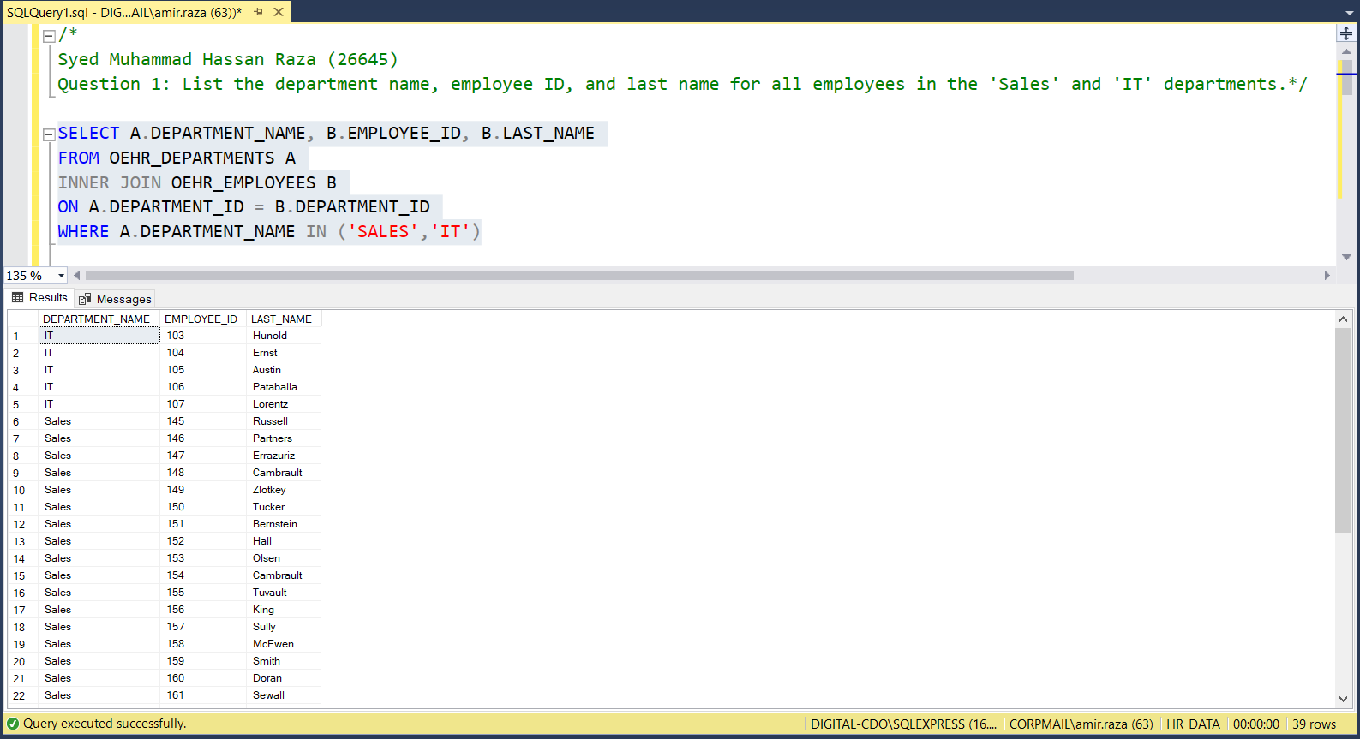

Question 2: Find the highest salary in the 'IT' department.

SELECT TOP 1 B.SALARY 'MAX SALARY'

FROM OEHR_DEPARTMENTS A

INNER JOIN OEHR_EMPLOYEES B

ON A.DEPARTMENT_ID = B.DEPARTMENT_ID

WHERE A.DEPARTMENT_NAME = 'IT'

Question 3: Show the number of employees in each department, but only for departments with more than 3 employees.

SELECT DEPARTMENT_NAME, COUNT (*) 'NUMBER OF EMPLOYEES'

FROM OEHR_DEPARTMENTS A

INNER JOIN OEHR_EMPLOYEES B

ON A.DEPARTMENT_ID = B.DEPARTMENT_ID

GROUP BY DEPARTMENT_NAME

HAVING COUNT(*) > 3

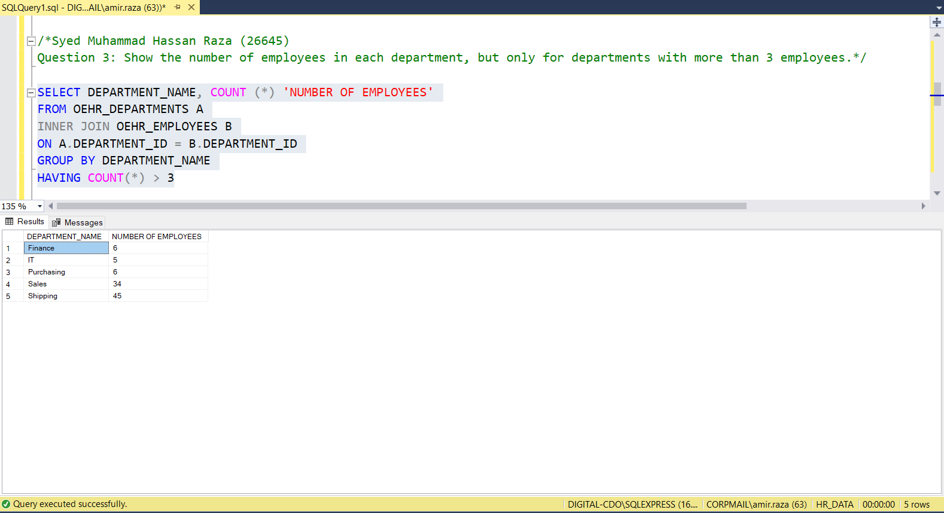

Question 4: List all employees who were hired in 2005. Those employees who were hired first should come first in your rows.

SELECT EMPLOYEE_ID, FIRST_NAME, LAST_NAME

FROM OEHR_EMPLOYEES

WHERE YEAR(HIRE_DATE) = 2005

ORDER BY HIRE_DATE ASC

Question 5: Display the average salary of each department, ordered by average salary in ascending order.

SELECT DEPARTMENT_NAME, AVG(SALARY) 'AVERAGE SALARY'

FROM OEHR_EMPLOYEES A

INNER JOIN OEHR_DEPARTMENTS B

ON A.DEPARTMENT_ID = B.DEPARTMENT_ID

GROUP BY DEPARTMENT_NAME

ORDER BY AVG(SALARY) ASC

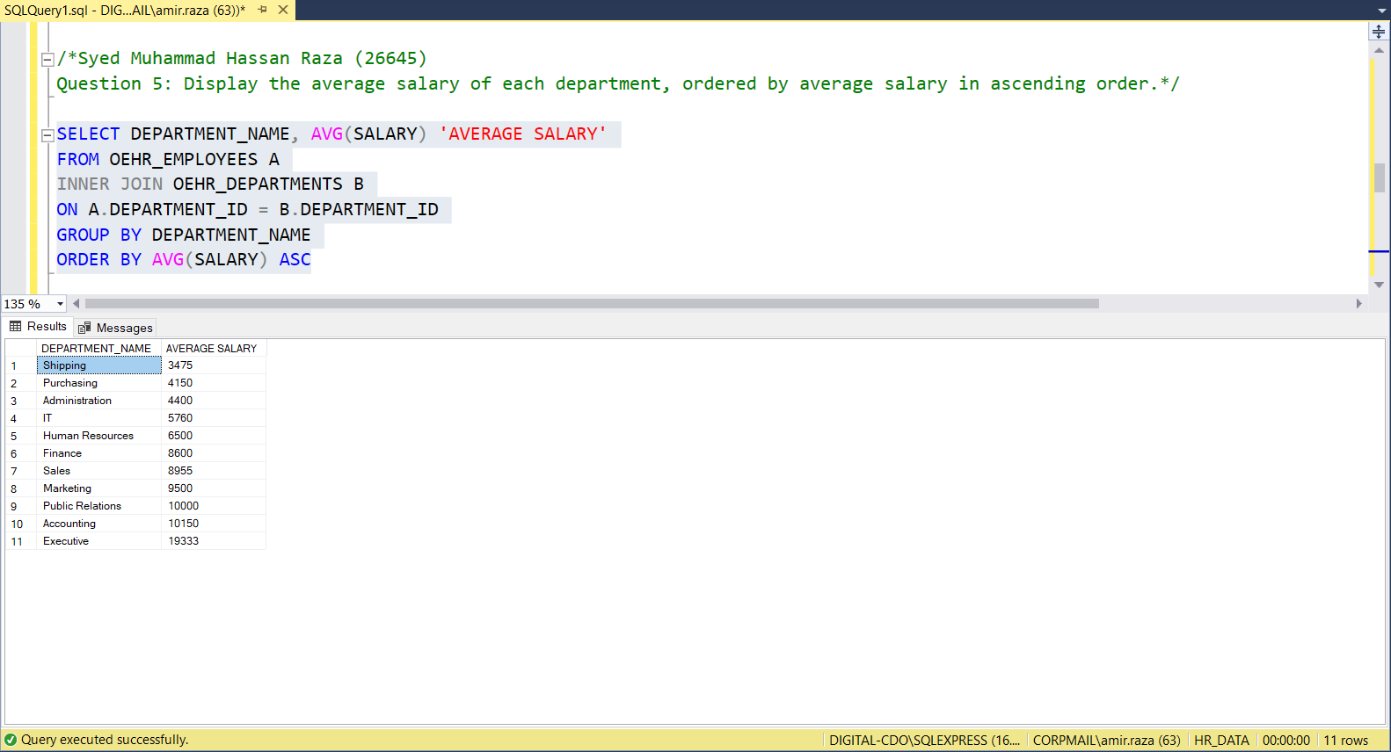

Question 6: Identify the departments where the lowest salary is above $3000.

SELECT DEPARTMENT_NAME, MIN(SALARY) 'LOWEST SALARY'

FROM OEHR_EMPLOYEES A

INNER JOIN OEHR_DEPARTMENTS B

ON A.DEPARTMENT_ID = B.DEPARTMENT_ID

GROUP BY DEPARTMENT_NAME

HAVING MIN(SALARY) > 3000

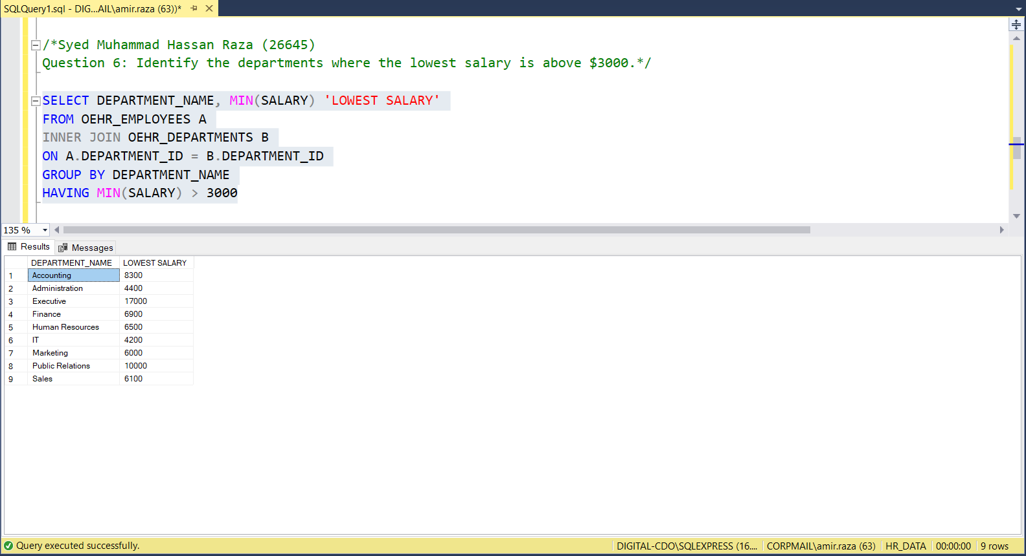

Question 7: List the job title and the difference between the highest and lowest salaries for that job.

SELECT JOB_TITLE, MAX_SALARY - MIN_SALARY 'DIFFERENCE BETWEEN MAX AND MIN SALARY'

FROM OEHR_JOBS

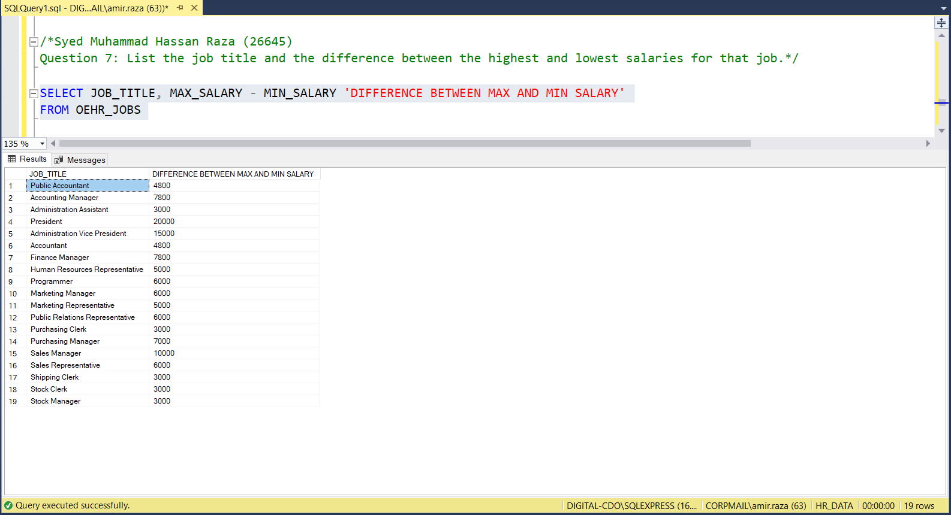

Question 8: Find all employees whose last name starts with 'S' and sort them by hire date in descending order.

SELECT *

FROM OEHR_EMPLOYEES

WHERE LAST_NAME LIKE 'S%'

ORDER BY HIRE_DATE DESC

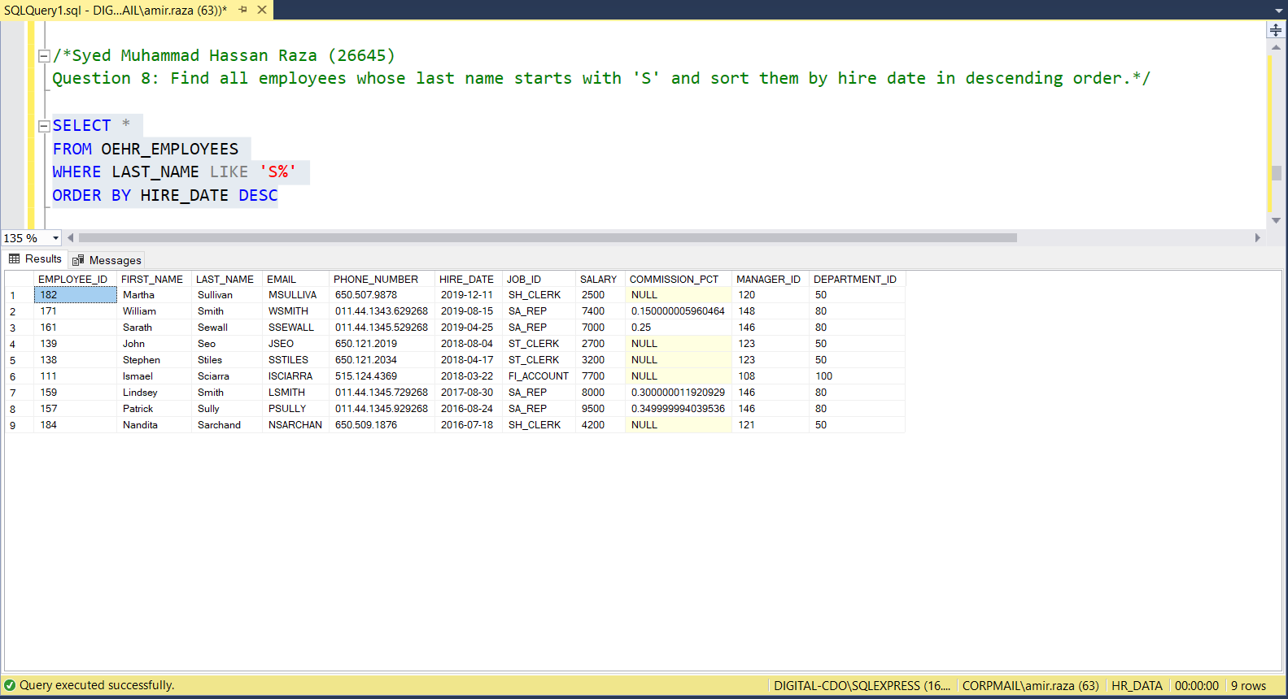

Question 9: Show each department's name along with the count of employees who earn more than $5000, only for departments with such employees.

SELECT A.DEPARTMENT_NAME, COUNT(B.EMPLOYEE_ID) 'NUM OF EMPLOYEES EARNING MORE THAN 5000'

FROM OEHR_DEPARTMENTS A

INNER JOIN OEHR_EMPLOYEES B

ON A.DEPARTMENT_ID=B.DEPARTMENT_ID

WHERE SALARY > 5000

GROUP BY A.DEPARTMENT_NAME

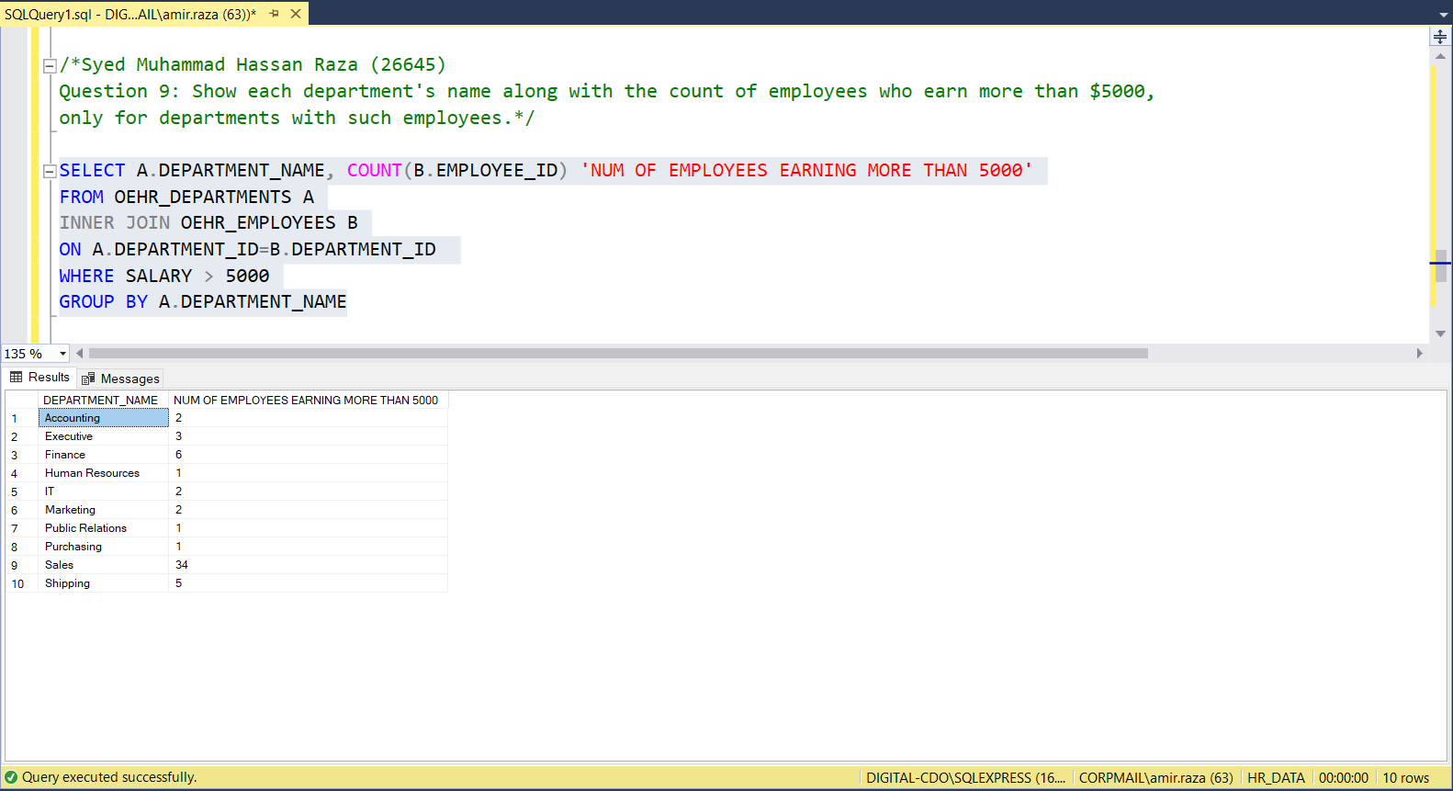

Question 10: For every employee, display their ID, last name, and a case statement that shows 'High Earner' if their salary is above 5000. Otherwise ‘Low Earner’.

SELECT EMPLOYEE_ID, LAST_NAME,

CASE WHEN SALARY > 5000 THEN 'HIGH EARNER' ELSE 'LOW EARNER' END AS 'SALARY TYPE'

FROM OEHR_EMPLOYEES

